**Practical 8**

Aim: Implementation spatial / web mining algorithms.

Objective: WAP to implement Page rank algorithm for a given graph

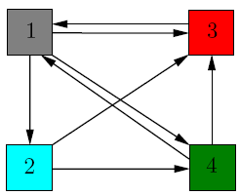

References:

<http://pi.math.cornell.edu/~mec/Winter2009/RalucaRemus/Lecture3/lecture3.html>

<http://www.cs.princeton.edu/~chazelle/courses/BIB/pagerank.htm>

<https://www.youtube.com/watch?v=3_1h13PJkUs>

**Algorithm**

I/P- initial graph matrix and N –no of nodes,

O/P- find page rank vector and k- no of iterations.

1) Read n-no.of nodes, initial graph using matrix

2) initial vector V0= [1/n, 1/n, 1/n..ntimes]

3)find M-n*n matrix where m[ij] = 1/k, where k = no of outgoing links from node j and one of them to node I

4) k=0,

4) Iterate until converge V

Vk= M*V k-1

k=k+1;

5) Print Vi and K- no of iterations

**Lab Questions**

1) Give the efficient approach to handle M and write reason

2) Give improvement of Page rank algorithm for spider trap problem and dead end